This document serves as a data dictionary and guide for the TRB 2017 transportation analytics contest. The daily trip matrix data (for the month of April 2014) produced by AirSage for this contest represents the travel pattern for Orlando Metropolitan Area.

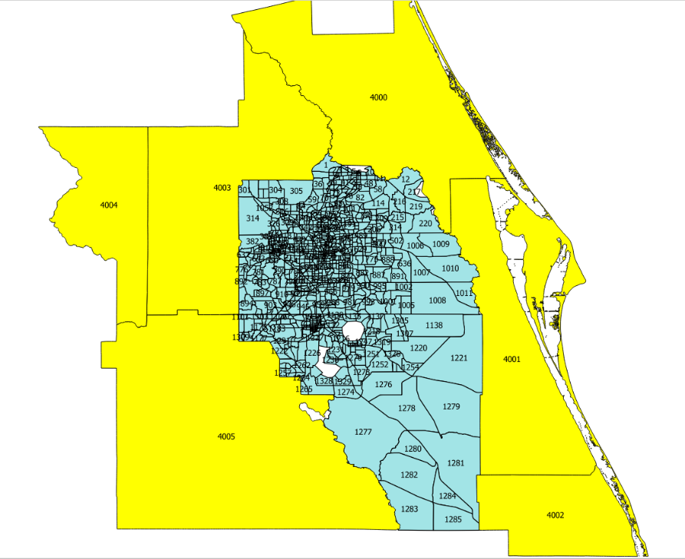

Figure : Study Area - Internal and External Zones

This study area is made up of 1267 zones (1261 internal and six (6) external zones) as shown in Figure 1. Each of the study zones are identified by a unique number between 1 and 4005, with 4000-4005 representing the external zones. Each of these zones are labeled using the “TAZ_ID” field in the included shape file.

The compressed folder (TRBContest_Deliverables_110116.csv.gz) included with this documentation contains 30 daily trip matrix files in the CSV format (one each for each day of April 2014), with each file reporting weighted (extrapolated) daily trips between the study area zones. Figure 2 presents an excerpt from a daily trip matrix file , with each record (or line) reporting the estimated number of trips (count field) between Origin (O)-Destination (D) pair segmented by: day of the month, hour of the day, trip maker, trip type, and trip purpose.

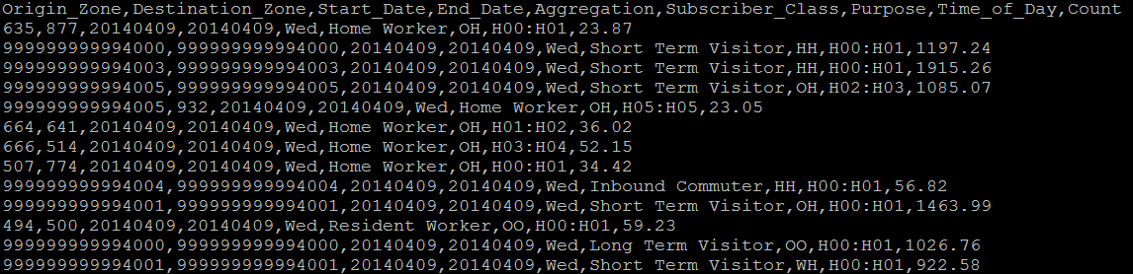

Figure 2 – Sample Daily Trip Matrix File Excerpt

Table 1 briefly describes each of fields (or columns) being reported in the daily trip matrix file and their enumerations.

Table 1 : Trip Matrix Field Description

|  |  |  |
| --- | --- | --- |
| Field Name | Field Description | Example Value |
| Origin Zone | The zone where the trips began (TAZ ) | 635 |
| Destination Zone | The zone where the trips ended (TAZ) | 877 |
| Start Date | The starting date of the travel demand reported in the trip matrix (YYYYMMDD) | 20140409 |
| End Date | The ending date of the travel demand reported in the trip matrix (YYYYMMDD) [Would be the same as the start date in each file as data for each day are provided in separate files] | 20140409 |
| Aggregation | Identifies day of the week corresponding to the date of travel | Mon, Tues, etc. |
| Subscriber Class | This field represent the type of trip makers , categorized based on their inferred home location, work location, and visibility in the study area (See Table 2 for further description) | Home Worker, Resident Worker, Outbound Commuter, Inbound Commuter, Short Term Visitor, and Long Term Visitor |
| Purpose | This field represent observed type of trip, categorized based on the beginning and end of the trip. | **H-W** : Home to Work,  **W-H :** Work to Home**,**  **H-O :** Home to Other,  **O-H :** Other to Home ,  **O-W :** Other to Work,  **W-O :** Work to Other,  **H-H :** Home to Home,  **O-O :** Other to Other ,  **W-W:** Work to Work |
| Time of Day | This field identifies the hour of the day to which the origin-destination demand corresponds to based on the start time of the trips | H03:H04 ; H18:H19 |
| Count | The weighted (extrapolated) sample trip estimate made by people with the given attributes, that started in the given Origin Zone and ended in the given Destination Zone during the given date and time range for user requested segmentation. | 5172 |

The origin and destination zones reported in each trip matrix file correspond the TAZ_ID in the shape file, except for the external zones. The external zones are prefixed with an 11-digit number (“9999 prefixes the external zone…”), and would need to be truncated by the contestants to match with the external zone id reported in “TAZ_ID” field.

Table 2 defines each subscriber type enumerated in the daily trip matrix file.

Table 2 : Subscriber Class Description

|  |  |
| --- | --- |
| **Subscriber Class** | **Description** |
| **Resident Worker** | Live and work in different locations within **internal** study area and seen for over 14 days or more |
| **Home Worker** | Live and work at same location within **internal** study area and seen for over 14 days or more |
| **Inbound Commuter** | Live in **external** study area **and** work in **internal** study area and seen for over 14 days or more |
| **Outbound Commuter** | Live inside **internal** study area **and** (work in **external** study area or **outside** study area) |
| **Short-Term Visitor** | Live and work locations in **external** study area or work outside study area; through travelers (seen for 2 days or less); |
| **Long-Term Visitor** | Live and work outside study area (seen for more than 2 days and less than 14 days). |

Although unintuitive, the file reports home and work based trips to be made by visitors. This occurs because the production scheme in place labels subscribers that have home/work in study area to be labeled as visitors as well. For example, short-term visitors includes subscribers who have home and work in external study area, and thus would include home and work based trips. There would also be a small share of home and work based trips reported by long-term visitors likely due to boundary cases. Overall, there would be trips reported across multiple purpose based on the trip end for all of the above subscriber class by hour of the day (00 to 24 hours), in which the trip was estimated to start.